**FULL ADDER**

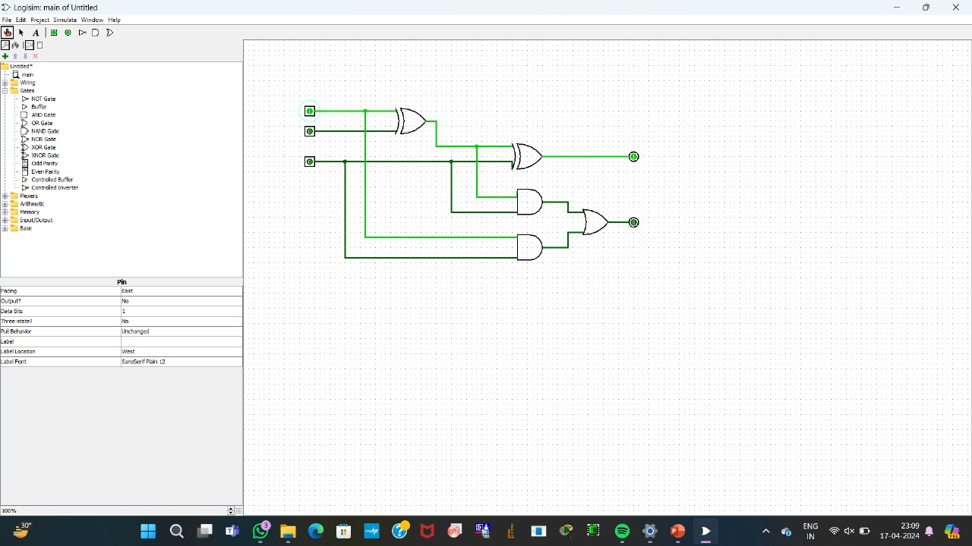

**1.Normal full adder**

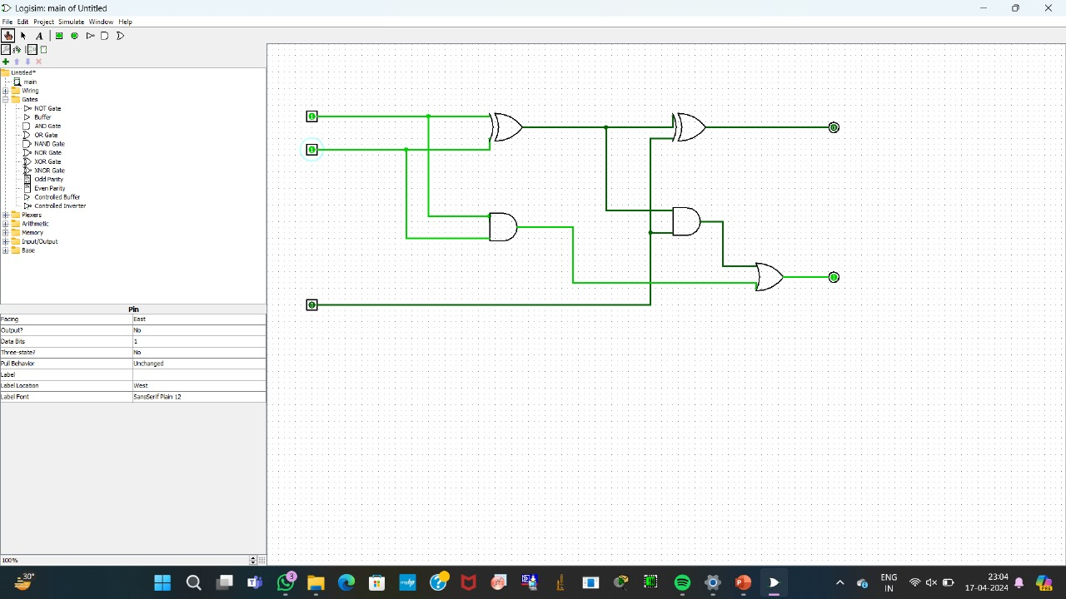

**2. Using two half adders**

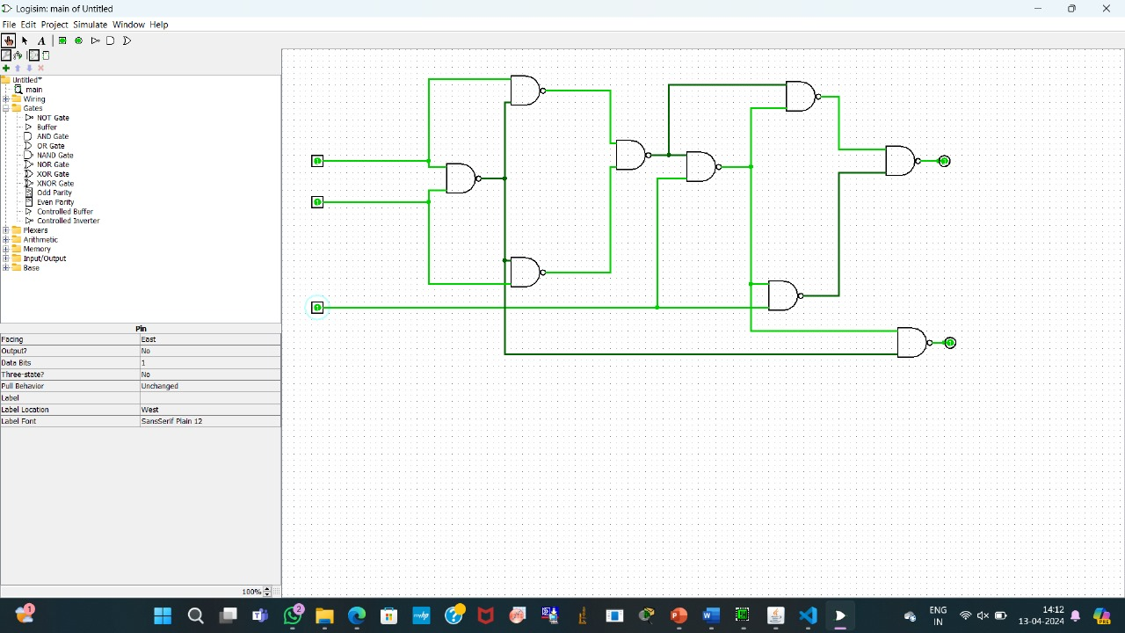

**3.Using NAND gate**

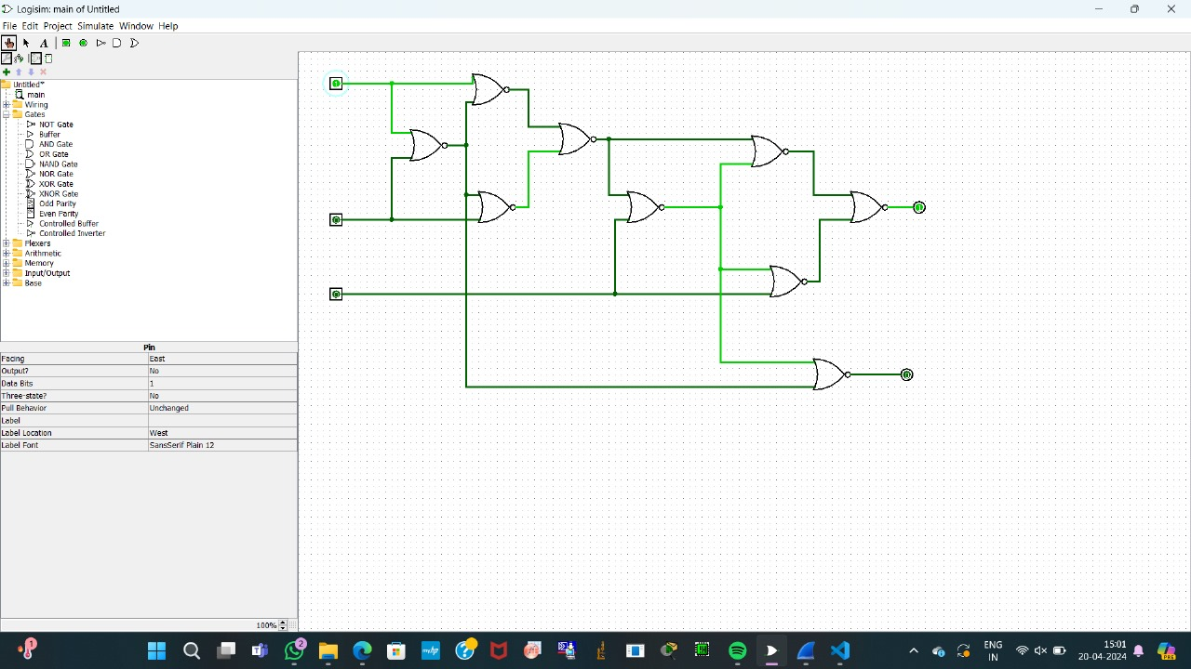

**4.Using NOR Gate**